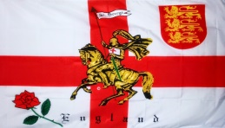
Bedfordshire DA
St Georges Meet @ The Birches, Wyboston
19th to 21st April 2024
We meet here with kind permission of Brian and Wendy Spiers
Friday
Meet opens at 11am
Set up, relax and take in the lighter evenings, hopefully the weather will be kind to us
From 7.30 come and join us in the shelter for a sausage in a roll with onion (optional) with a natter n chatter, please bring your tipples, nibbles and chairs. Prepare for a St Georges quiz and anything else we can think off
Saturday
2.30 We will be serving cream teas. Please bring your cups, plates & a knife.
Monetary donations would be welcome.
Weather permitting there may be some light hearted games in the afternoon please join in for a bit of fun
7.00 onwards Come and join us in the shelter, bring your tipples, nibbles and chairs. There will be a quiz during the evening and anything else that is entertaining!!! Any suggestions welcome
Sunday
10.30 Coffee /Tea and biscuits and please pay any fees that are due.
We hope you all have had a pleasant and amusing time. Could you please take all your dry waste home with you Thank You Have a safe tow home and see you on a rally field again soon.
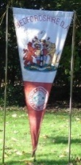
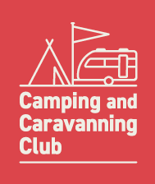
Stewards: 07956525585 - Val
07957654781 – Steve

The Camping & Caravanning Club, Greenfields House, Westwood Way, Coventry, CV4 8BR
Tel : 024 7647 5448

